

TOll Database System



MD. Peyal Molla

Department : Computer Science and Engineering

Roll : 1507043

Submitted By

Submitted To

June 26, 2019

**Jarin Firose Moon Md. Milon Islam**

Lecturer Lecturer

Department: Computer Science & Engineering Department: Computer Science & Engineering

Khulna University of Engineering & Technology Khulna University of Engineering & Technology

**Project Overview**

**Brief Description:**

* The main objective of this project is to maintain the system of taking toll in a toll center.
* It can also detect if a vehicle is fit for ride or not and if there is any police verification problem.
* Calculating bill for passing a specific toll center.
* Deducting bill automatically from the user’s account.
* Provide the bill recipt.
* Detecting the way that a vehicle have passed.

**Database Structure Description:**

Toll database system is a special database system made for storing the data of all the toll center of a country. These data can be analyzed centrally. In every country there are many toll center for bridge or culvert. So there need a toll office for collecting the bill. These are done manually, but we can make it automatic and database based. And for doing so this system is made.

There are four tables:

**1. Vehicle Table**

**2. Owner Table**

**3. Police Table**

**4. Toll Office Table**

***Vehicle Table*** is consist of vehicle id, vehicle type and bill. The bill is made according to what type of vehicle it is.

***Owner Table*** is consist of owners detail information like name, address, included vehicle, license, account from where the bill will be deducted. An user can have many vehicle, and also one type of vehicle can be of different user’s.

***Police Table*** is consist of owner id who has done any crime, crime type and time.

***Toll Office Table*** is consist of id of that toll center, id of the driver, time of passing that toll center and the bill of his vehicle.

**Functionality:**

The database allows to complete the following functions:

* User can easily pay the bill of toll center from their account.
* Toll office can easily detect if there is any police case with the user.
* All the information are kept safe.
* The root of the vehicle can be easily detect, helpful for police.
* The details of information about passing a vehicle through a toll office are stored.

**Audience:**

The main audience or user is the toll office and driver. Both party can get help from the system. The driver passes through a toll center and the toll office keep that information and also deduct the bill. It also detect if the vehicle is fit or not for ride.

**Database Design Process:**

Our goal was to create a practical based database management design system. It was developed in Oracle. It was designed in Toad. Some planning, design, and review of the existing prototype were researched to build the project. Five tables were designed to maintain the shopping system. Our table design provides future flexibility for growth and changes to the database tables. We learned several important lessons through the design process.

These include:

* Designing the tables is the most important step and must be done early in the project.
* Building a database from scratch is often easier than revising an

existing database.

* Initial design is so important.
* Being able to design a database well for a client requires a lot of understanding about the business process and needs behind the applications.

**Future of the Database:**

The database is currently functional as a practical application of an Toll Management system. It is completed with Oracle and Toad.

It is anticipated that the following tasks will need to be accomplished in order to achieve the goals:

* Create the database tables in Oracle and Toad.
* Update code to incorporate feedback.
* Develop information for needed forms and database tables to support the form.

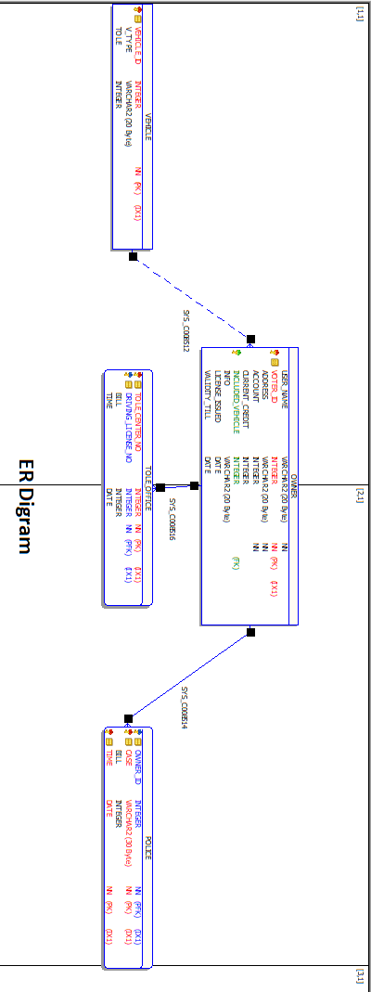

**Schema Diagram:**

|  |
| --- |
| Vehicle |
| Vehicle_id |
| V_Type |
| Tole |

|  |
| --- |
| Owner |
| User_name |
| Voter_id |
| Address |
| Account |
| Current_Credit |
| Included_Vehicle |
| Info |
| License_issued |
| Validity_till |

|  |
| --- |
| Police |
| Owner_id |
| Case |
| Bill |
| Time |

|  |
| --- |
| Toll Office |
| Toll_center_no |
| Driving_License_no |
| Bill |
| Time |

**Summary:**

The project was a learning experience as this was a pretty small project as we have learned database very first time. Thus the project has helped to better understand user level application of databases how the different tasks and operation can be done in the database. Thus we have also about some programming which can be done to get certain output from the database.